QA Tools Training Program:

Module-4 Assessment

==============================

1.Write a python script using selenium for automating the process of searching for a specific product on Amazon and extracting information about the first few results. Specifically, you need to:

1. Open Amazon's homepage.

2. Search for a specific product (e.g., "laptop").

3. Extract information about the first 5 search results, including:

Product title

Product price (if available)

Product rating (if available)

Number of reviews (if available)

4. Print this information in a structured format.

**CODE**

import os  
from selenium import webdriver  
from selenium.webdriver.common.by import By  
from selenium.webdriver.common.keys import Keys  
  
os.environ['PATH'] += r"D:\chromedriver-win64"  
driver = webdriver.Chrome()  
driver.get("https://amazon.in")  
  
search_box = driver.find_element(By.ID,"twotabsearchtextbox")  
  
search_box.send_keys("laptop")  
search_box.send_keys(Keys.RETURN)  
  
results = driver.find_elements(By.XPATH, "//div[@data-component-type='s-search-result']")[:5]  
for index,result in enumerate(results, start=1):  
 title=(result.find_element(By.XPATH,".//span[@class='a-size-medium a-color-base a-text-normal']").text)  
 try:  
 price= result.find_element(By.XPATH,".//span[@class='a-price-whole']").text  
 except:  
 price ="N/A"  
 try:  
 rating = result.find_element(By.XPATH,".//span[@class='a-icon-alt']").get_attribute("innerHTML")  
 except:  
 rating ="N/A"  
 try:  
 reviews = result.find_element(By.XPATH, ".//span[@class='a-size-base s-underline-text']").get_attribute("innerHTML")  
 except:  
 reviews = "N/A"  
  
 print(f"results {index}:")  
 print(f"title : {title}")  
 print(f"price : {price}")  
 print(f"Rating: {rating}")  
 print(f"Number of Reviews: {reviews}")  
 print("-" * 20)  
  
driver.quit()

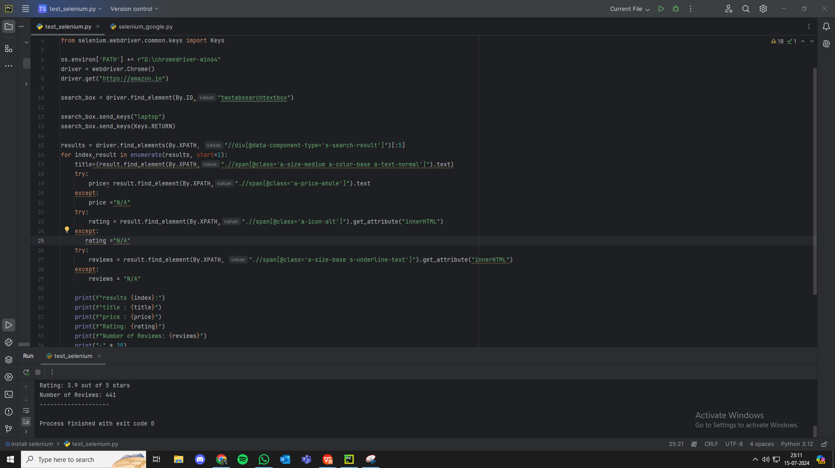

Code screenshot

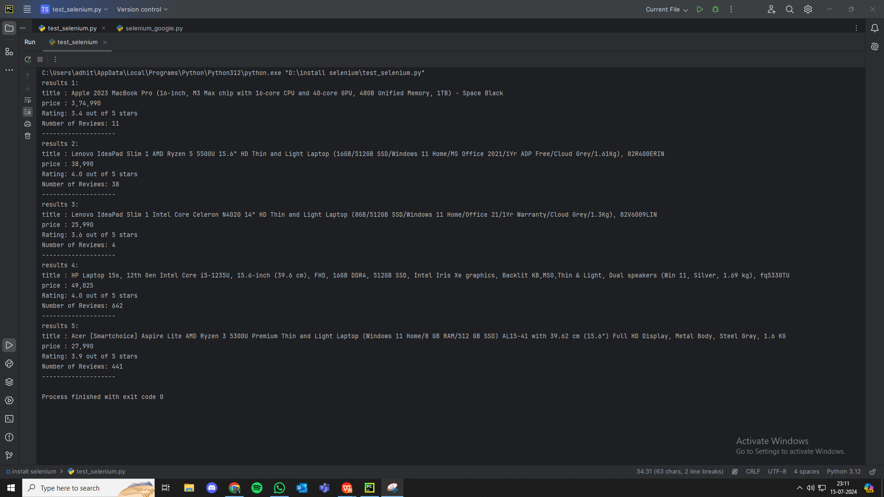

Output screenshot

1. Create a new data in any of the open source server modify them and delete them using Postman.

Answer:

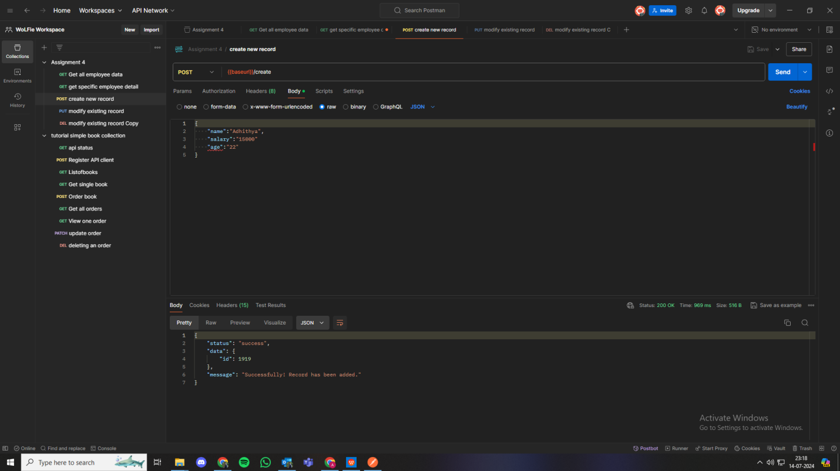

Using POST method to input data to the rest api.

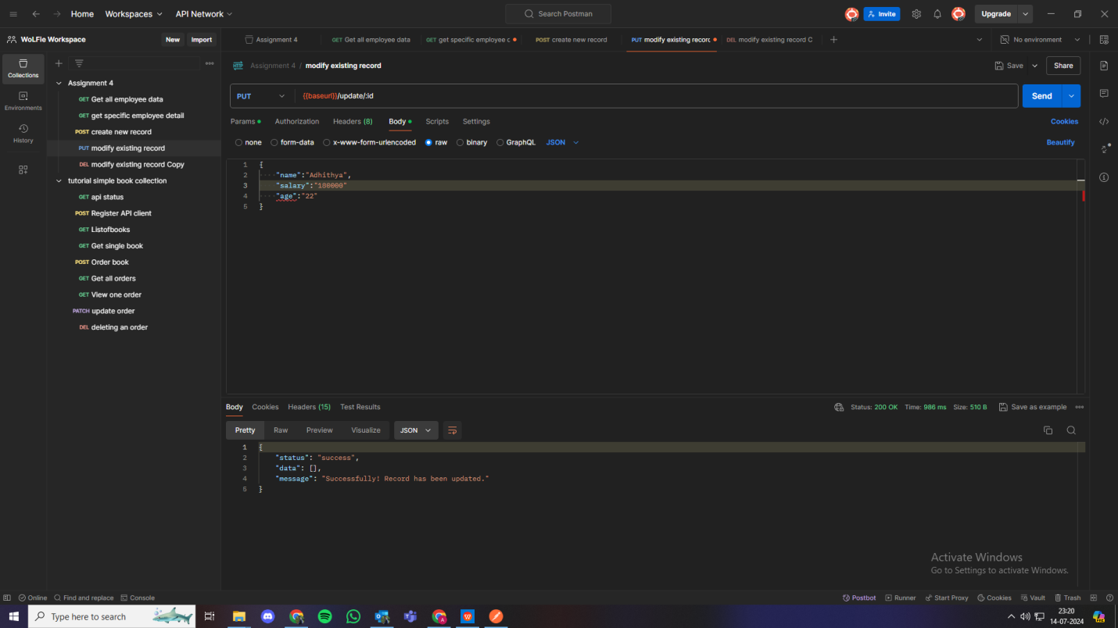

Using PUT method to modify the data uploaded in POST method.

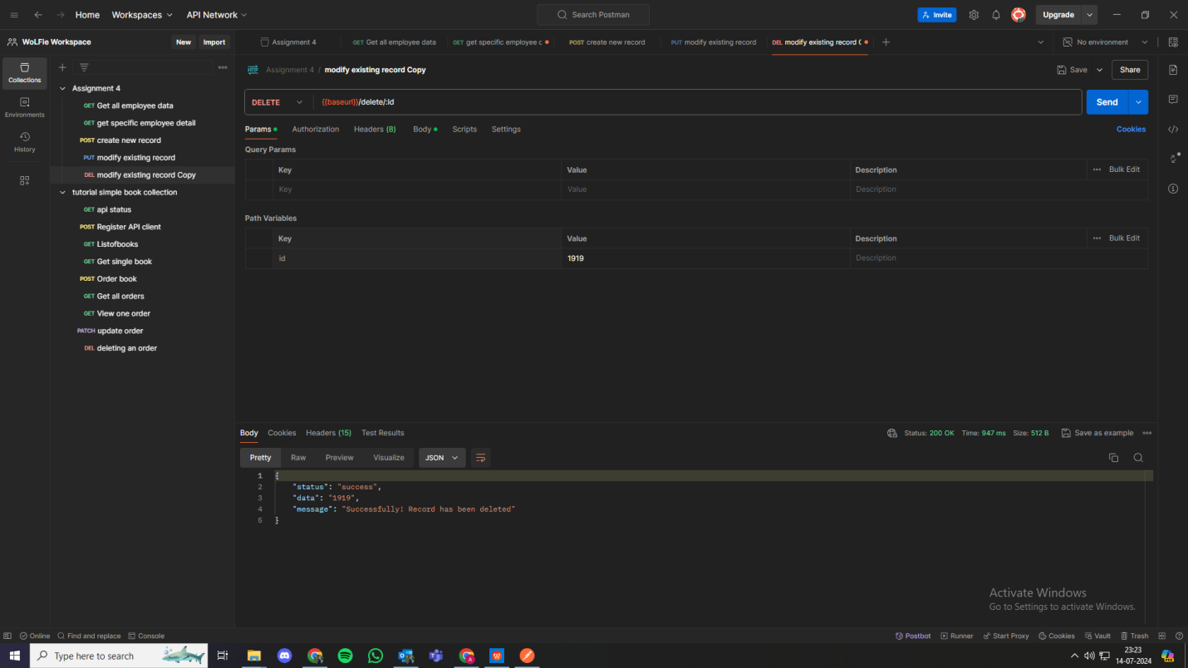

Using DELETE to delete uploaded data.